**Create A Dashboard On Translists Report**

Create  a dashboard on Translists report:

Go to the app ? click on the Dashboards tabs.

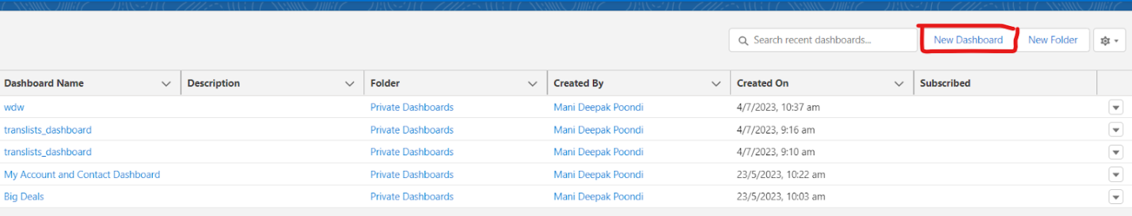

1. Click on New Dashboard.

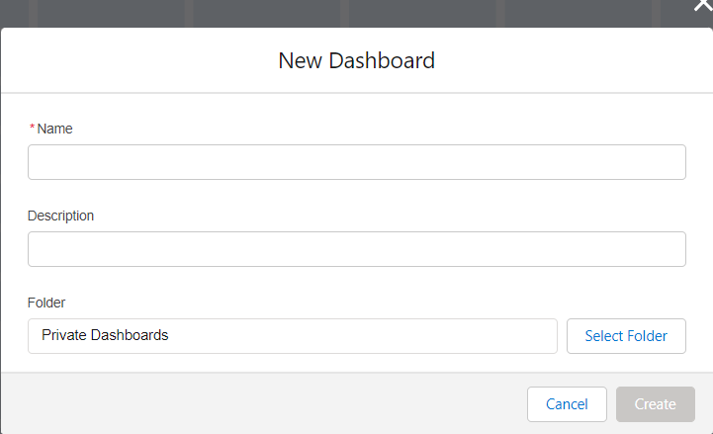

1. Enter the Name of the dashboard and description(optional).
2. Upon clicking create, you will notice an empty dashboard. Click on New component.

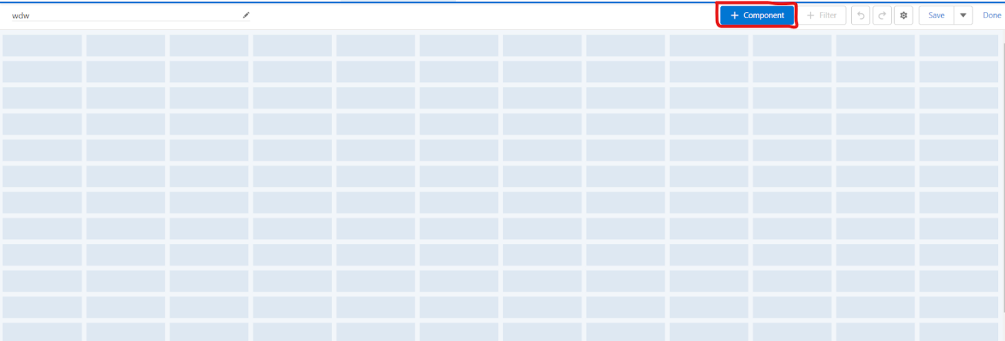Click on “**+** Component”, and click on translists report.

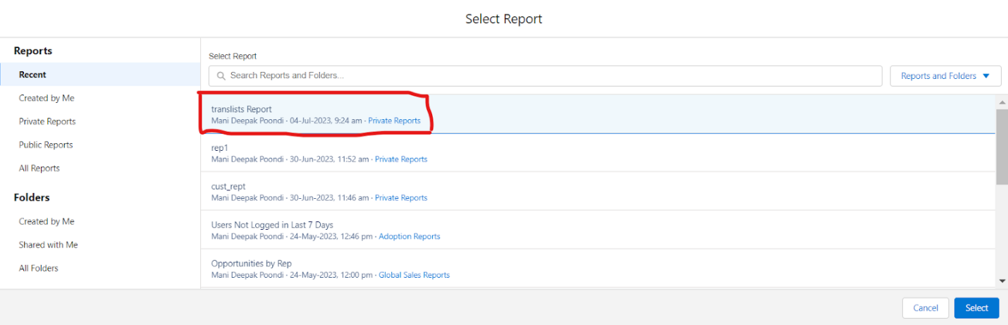

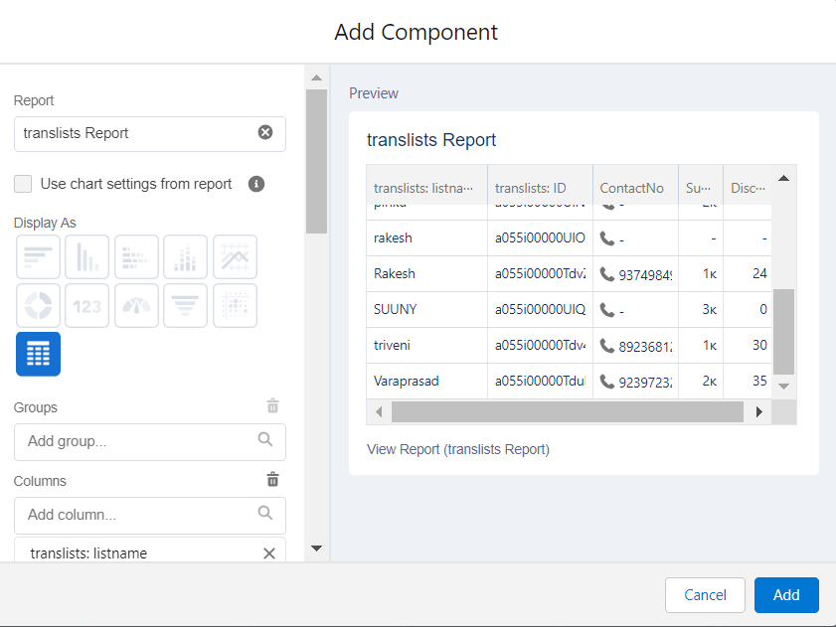

Click on select and in the add component section, select all the fields required for the dashboard. Click on add component and add

display as pie chart view.

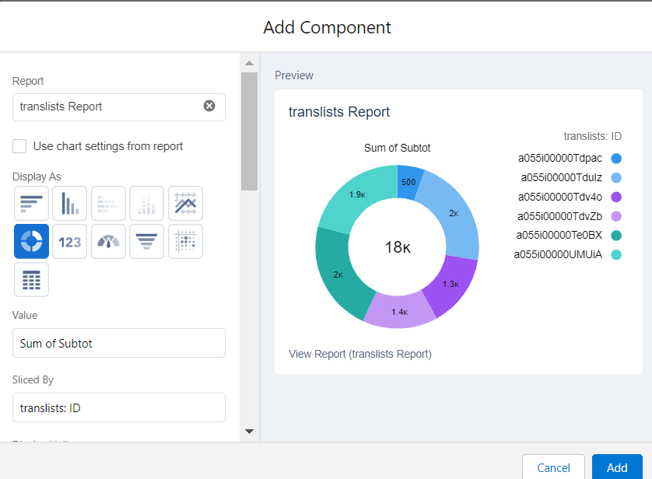

8)Add another component on translists reports, select Gauge representation and add the component.

9) Select the Measure as Record count( to maintain the number of transaction count) and select the checkboxes Show Percentages, Show Values and Show Ranges.

10)Add segment ranges as 0,10,30,50 and add the component.

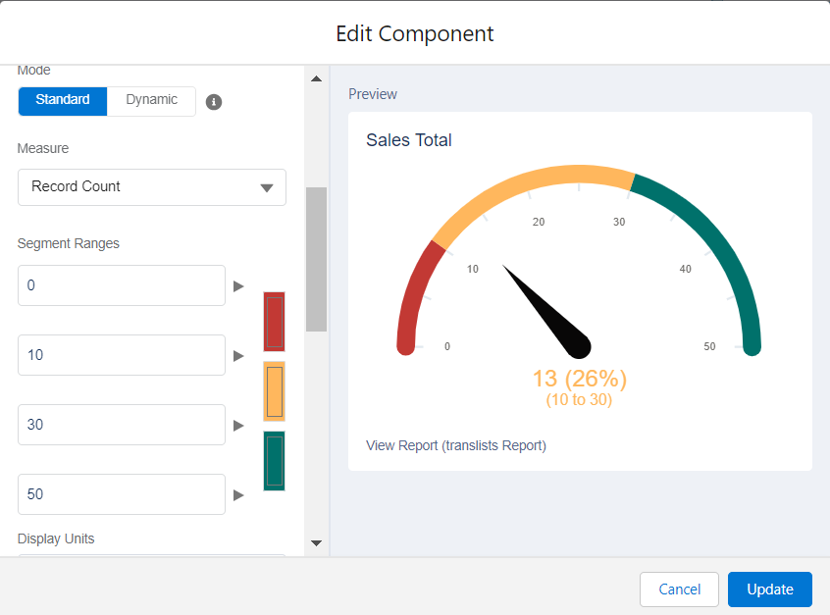7) You will view the translists report on the dashboard page. Click on done and Save.

7) You will view the translists report on the dashboard page. Click on done and Save.

**USE CASE:**

After creating dashboard for the translists object , we can get to know the aggregate expenditure of the customer and thus we can effectively communicate with them and get to know  the valuable customers.

Hello Sir,

Here I have Problem how can i translate Custom Reports and Dashboards name in other language

I can translate label and field in other language but here i unable to translate Reports and Dashboards name in Other language....

so what can i do to translate these custom reports and Dashboards name...

Here i have snapshots of the problem

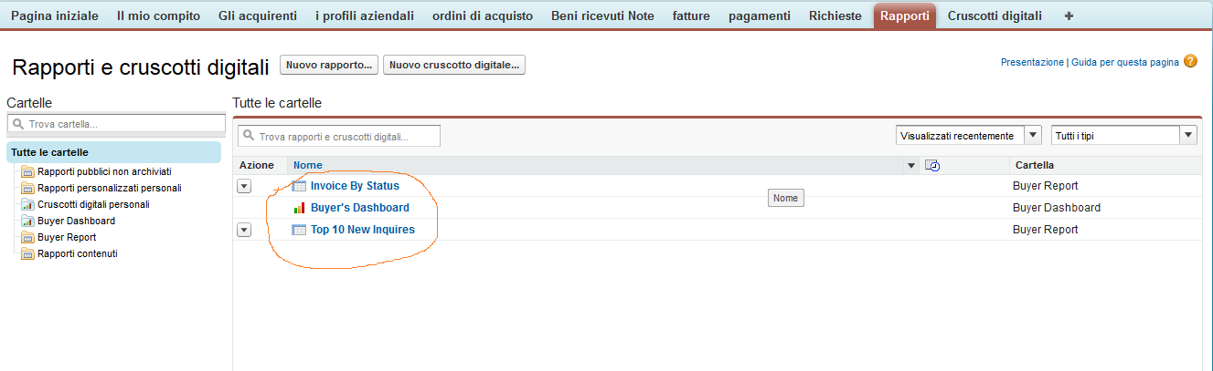

Here in Snapshot Rounded reports and dashboards name is not translated....

So please help me to translate these name...

Here is the another Dashboard snapshot in that also Dashboard name is not translated...

